CARCAL version 2.0

User’s manual

version 2.2, August 2011



By A.M. van Roon and L.J.M. Mulder.

Contents

Preface 4
Chapter 1: Aims of CARCAL 5
Chapter 1: Aims of CARCAL 6
Chapter 2: Getting started 7
Chapter 3: Operation details 9
3.1 Blood pressure 9
3.2 Respiration 11
3.3 Filtering of a channel 13
Chapter 4: Algorithms 14
4.1 Blood pressure 14
4.2 Respiration 15
4.3 Filtering 15
Chapter 5: Customizing your program 16
Appendix: Known blood pressure calibration signals. 18

Preface

Calibration of sample values is an issue for all digitized signals. CARCAL’s early predecessors were derived from EEG calibration programs. BPCAL was designed to calibrate blood pressure signals and was already running on a DEC PDP-11 machine, written in FORTRAN. Of course, no user interaction was included besides “Enter file name:”. But even manual calculation was still common practice. Since the introduction of CARSPAN version 2.0, a new way of scaling was introduced. This resulted in programs that calculated “new zero” and “new scale” values. Also the (Visual Basic 6.0) Windows version calculated old and new calibration values. In this program, a signal histogram has been used to determine the two levels of the signal that correspond with the reference values. This method is also used in this Delphi 7.0 version that returns only the new kind of scale values for blood pressure signals.
The program is expanded with a respiratory section. If the subject has been breathing with a know tidal volume, this part of the signal can be selected and used for calibration of the values.
Therefore, a new name is introduced: CARspan CALibrations.

The introduction of a filter option for the respiration calibration, made us decide to include a more extended filter option for a channel. This major extension was the reason to introduce version 2.0. Screens with version number 1.0 in this manual still apply to version 2.0 because only the tab ‘Filter’is added to the program.

Arie van Roon, September, 2009.
CARSPAN processing overview

Event file Sample data file Secondary event file
CarCalFil
Calibrate signals and filter channels.
PreCar
Inspect signals, detect R-peaks, or add segments (block codes).
CARSPAN
Correct R-peaks, add and correct new time series, spectral analysis.
Carousel
Select specific output parameters, easy inspection of spectra or calculate new parameters
Statistical analysis
Analyse spectral data using Excel or SPSS

Chapter 1: Aims of CARCAL

Blood pressure
After digitizing a blood pressure signal, the true values (in mmHg) are converted to dimensionless values determined by the analogue to digital conversion (A/D conversion). The range of the numbers depends on the resolution of the conversion (usually in bits). However, to analyze the pressure signals with CARSPAN, true values in physical units are required. The appropriate way to scale the numbers is to evaluate a reference or calibration signal, supplied by the blood pressure device, with known values in mmHg.

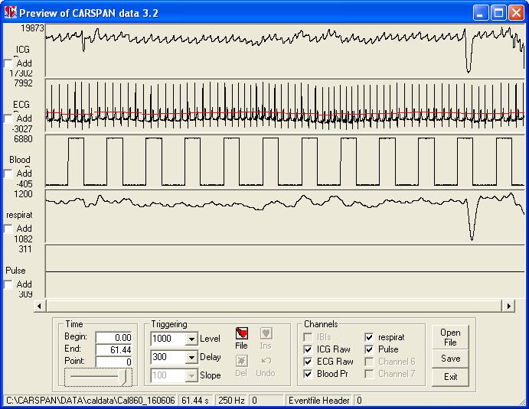

The signal in the middle panel is a typical blood pressure calibration signal. The lower values correspond to 0.0 mmHg, while the high values correspond to 200.0 mmHg. On the left side of the panel, you can see the range of the numbers after A/D conversion: approximately -200 to 6400. Assuming that the A/D conversion is linear, the scale value is 200/6600≈0.03 mmHg The zero value is in this case -(-200)x0.03=6.0 mmHg. We just performed a manual calibration; the program’s aim is to do it for you! The calibrated new values are calculated by multiplying the sample values with the scale and add the zero value.

Respiration
If a subject breaths with a know tidal volume for a short period of time, this part of the data can be selected for calibration of the respiratory signal. The respiratory amplitudes are calculated for this section and the know tidal volume (in ml or cm³) is divided by the mean amplitude to calculate the scale factor. The mean of the minima of the breaths are used to calculate the zero value. Scaling the signal in this way, expiration values are close to zero and end inspiration values nearly equal to the calibration tidal volume.

Chapter 2: Getting started

The start-up window looks like this:

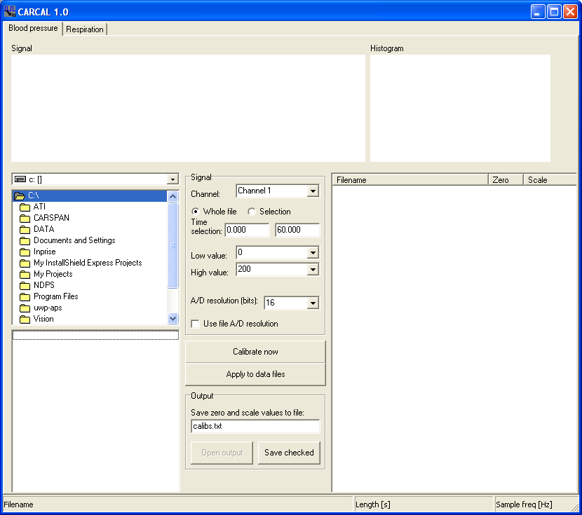

The drive combobox and directory list can be used to browse to your data files with recorded calibration signals. Click on a file and thin the file is opened to determine the channels. It automatically detects a blood pressure channel. Now, click on “Calibrate now” and the signal is shown top left and the corresponding histogram top right. The result is show in the list on the right side of the window. A checkbox, filename, zero and scale values are listed. You can use the values for the calibration of the blood pressure signal of files in CARSPAN.

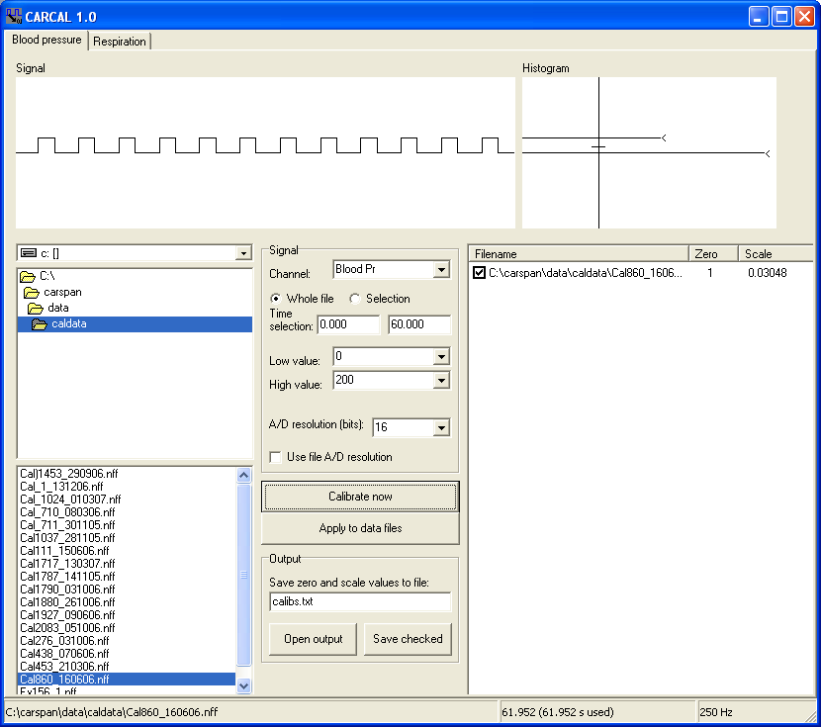

The values are entered in the CARSPAN data specification.

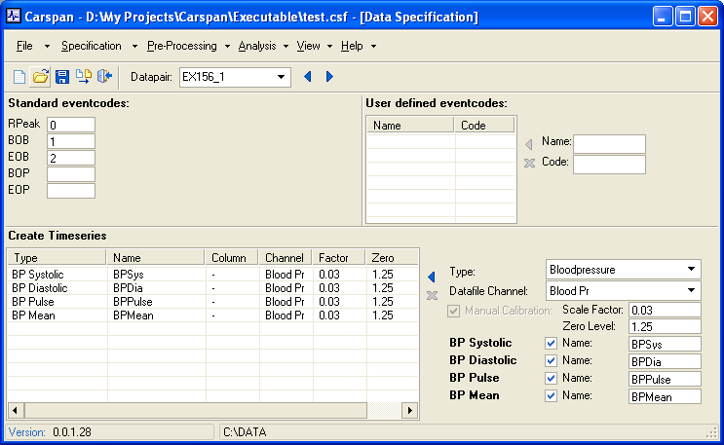

Chapter 3: Operation details

3.1 Blood pressure

Signal specifications
Before starting a calibration, the setting for the calibration signal must be defined. First of all, the channel of the sample file that contains the calibration signal has to be selected. The combobox contains all channels that are available in the selected file. The program automatically recognizes the blood pressure channel if the channel names in the file contain one of the specified keywords (see chapter 5).
The calibration signal must have two specified levels that correspond with specific blood pressures. These levels are specified by means of the two comboboxes Low and High value. You can select one of the pre-defined values, or enter your own in the box.
The A/D resolution must be specified to limit the range of values for the histogram. Usually, the resolution is specified in the data file and this value can be used by checking the box “Use file A/D resolution”. In case of a missing value or an incorrect value, you use the combobox to specify the correct value before starting the calibration process.

Calibration
To start the calibration, click “Calibrate now”. The calibration signal is shown as well as the corresponding histogram. A vertical line in the histogram indicates the cut-off value to detect the two peaks in the histogram that correspond with the Low and High value. These peaks are indicated by a “<” sign.
If, for instance, only one value is found, click in the histogram graph to point out a better cut-off value. A new calibration is performed and the new results are displayed. This process can be repeated until you agree with the solution.
The values are shown in the table at the bottom right side of the window. Each time to you calibrate, a new line is added. You can check/uncheck lines that are valid/invalid. If the zero and scale could not be calculated the values are set to “n.a.” (not available). This occurs when only one or no level is detected. In case of questionable values, question marks are added before the number. This usually will occure when you select a channel that contains a measurement in stead of a calibration signal. In the example below, ECG is selected on purpose with the questionable results. These lines are automatically unchecked.
If the range of the Y-axis of the graph is too large or too small, use the A/D resolution setting to adjust the range.

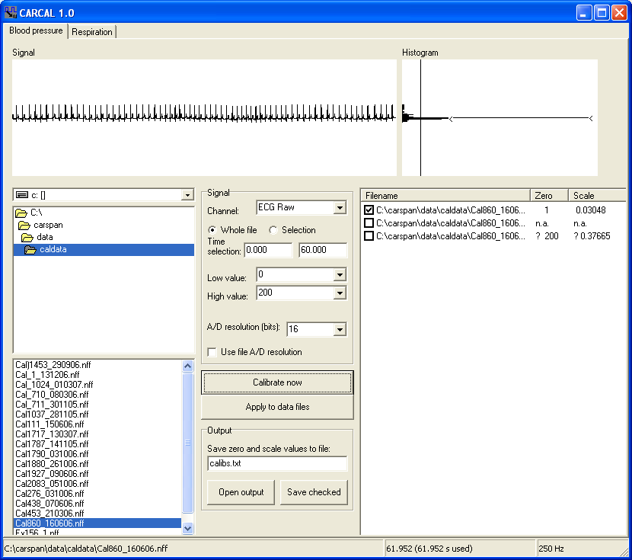

To continue, select the next file to calibrate, or produce an output file.
The unit of the zero and scale values is the pressure unit, usually mmHg. The accuracy of pressure signals is in most common systems 0.1 mmHg. Differences in zero level less then 0.1 mmHg are therefore not of importance. Scale values should be supplied with 4 significant numbers.

Apply to data files
A zero and scale value can be saved in data files for easy further processing. Select one row in the list with available calibrations (the line becomes blue). Now, press “Apply to data files” and select one or more data files in the file dialog box to which the selected zero and scale apply. Click on “Open” to start the process. In all files, the blood pressure channel information will be updated with the values, date of calibration and the filename of the calibration signal used to calculate the zero and scale. Note that the blood pressure channel in the data files should be the same as in the calibration file.

Output file
When you are finished with calibrating your files, you can store the calibration values. Enter a file name in the editbox. You can include drive and path, but if you specify just a name, it will be stored in the current file directory. Select the correct calibrations in the list by checking these only. Then, click on “Save checked”. If your output file already exists, a question pops up. If you want to append the results, choose, “Yes”, otherwise, choose “Cancel” and change the output file name in the editbox.
If an output file is present, you can open it with Excel by clicking on “Open output”, but this will of course not function if Excel is not installed on your system. The output file has a simple structure: each line contains calibration file name, zero and scale. Tab’s are used to separated the values.

3.2 Respiration

Signal specifications
Before starting a calibration, the part of the respiration signal must be selected that is used for calibration. Select the data file in the left panel and click on “Plot”. By default, the whole file is plotted and this can take a while. If you know the approximate start and end times of this part of the signal, choose “Selection” and enter these times (in seconds) in the two boxes behind “Time selection”. This will save time in case of long recordings.
Another way to select is by clicking on the start position in the signal window. Then, move with the left button down to the end and release the left button. The selected part of the signal is inverted, begin and end time are automatically entered in the edit boxes. Click on “Plot” the zoom in on this part of the signal.
Vertical scaling can be manual (enter the values in the edit boxes on the left side of the signal window) or automatically (check the box “Auto”).
The used calibration value in milliliters must be entered in the edit box before calibration.
If the signal must be filtered, check “Apply low pass filter” and enter a cut off frequency in the edit box behind it. Note that the lower the frequency, the longer the filter process will take.

Calibration
Use the scrollbar, on the left side of the signal panel, to adjust the level for the detection of cycles. To start the calibration, click “Calibrate”. The selected signal and detection level is used to detect respiratory cycles. The parameters of each cycle are displayed in the list and are preceded by a check box. If checked, then the cycle is included in the calculation of the statistics, zero and scale value. N.A. means that this value is not available for the (set of) cycles.

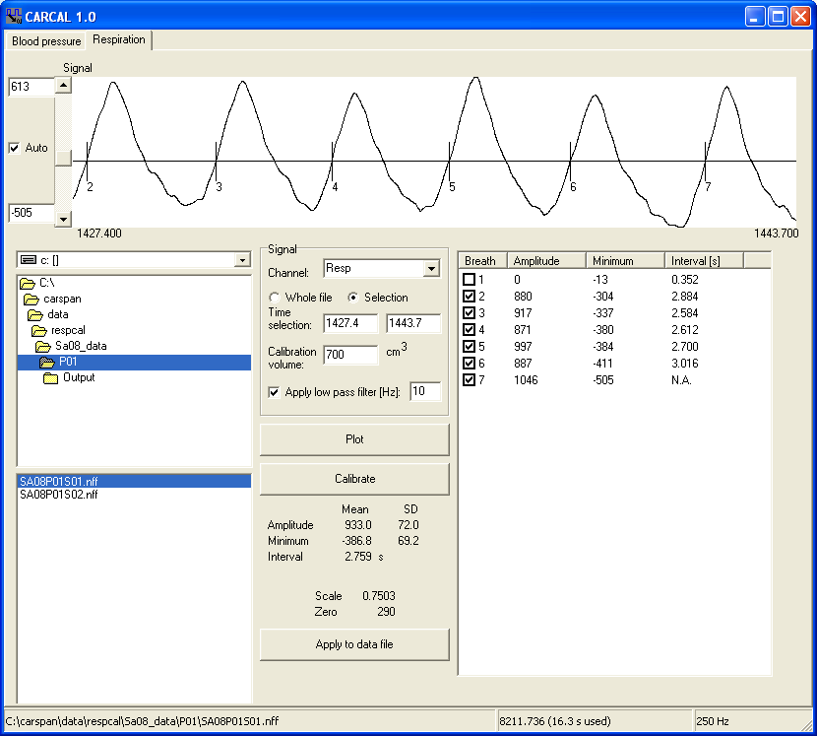

The mean minimum is used for determination of the zero value and the mean amplitude for the scale.

Apply to data file
The zero and scale can be applied to the current file only. This is because the calibration is an individual process and the scaling will be different each time the respiratory measurement device is (re)placed.

3.3 Filtering of a channel

Sometimes the detection of R-peaks or blood pressure values can be performed better if the signal is filtered first. Most common is a clearly visible 50 Hz signal added to the ECG. After applying a filter, R-peak detection will be much easier to perform.
Start with selecting a file from the list at the bottom left. File length (in seconds) and sample frequency are shown at the status bar. Select a channel to filter, in the current case the ECG is selected. In most cases, use a selection of the file to plot in the graph at the top, because for files over 500 s drawing the signal will take a wile. By default, one minute of signal is drawn.
Define your filter by choosing the number of points. The list with points and their weights is adapted to the number you enter. If you enter a even number, an odd number is listed and the first and last weights are set to 0.5 (the others are set to 1). In this way, you will always design a filter with zero phase shift (necessary to maintain synchronicity with the other channels).

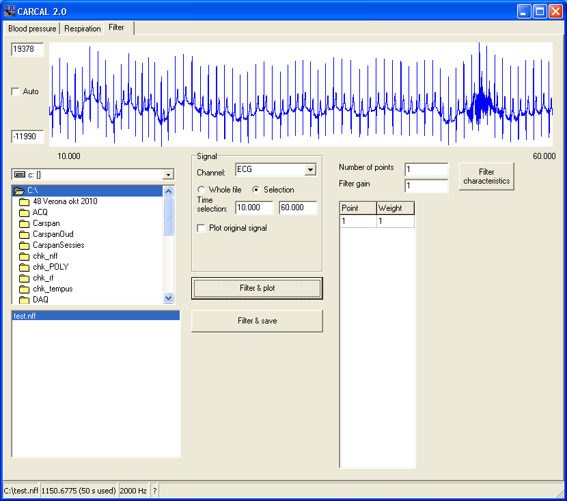

Click on Filter characteristics to plot a graph of the transfer function of the designed filter. Overall gain can be adapted by the filter gain.
Filter the signal by clicking on Filter & plot. The original signal is plotted (black, only if ‘Plot original signal’ is checked) together with the filtered signal (blue). Use Filter & Save to overwrite the signal in the file by the filter signal. Note that there is no restore option, so use only copies of original data files! A popup question to confirm the overwrite is included.
Scaling of the graph can be changed by un-checking ‘Auto’ and use the text boxes left of the graph to enter fixed minimum and maximum values of the graph.

Chapter 4: Algorithms

4.1 Blood pressure
The histogram h(i) is calculated by counting the appearances in the signal x of all possible sample values i in the range specified by the A/D resolution K. The signal length is the file length or truncated to a specified maximum time length (see chapter 5) and results in N samples. The mean value of the signal x is calculated by:
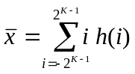

Now, starting with i=-2^{K-1}, the first maximum i=m1 is detected but only if h(i) values are above the cut-off value. Then, a second maximum i=m2 is detected for h(i) above the cut-off value and x above the mean value of x.
Results are questionable (indicated by a ? character) if:

- the percentage of counts p near the maxima m1 and m2 is less than 2%:

- (m2-m1)<2^{K-7}, meaning that the two maxima should be far apart (>1.3% of the whole range).

The final calibration values are:

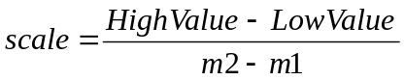 and 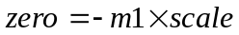

The sample values x are scaled to calibrated values y using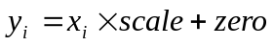.

4.2 Respiration
The mean of the selected signal part is calculated and the detection is set to the mean by default. The detection level can be adjusted manually (with the scroll bar, see chapter 3.2). A breath is detected when the signal value exceeds the detection level. The preceding minimum and succeeding maximum is used to calculate the amplitude. Respiration interval is calculated between this and the next exceeding of the detection level.
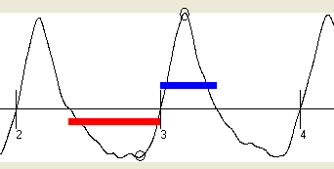

The bar below the line of the detection level indicates the search area for the minimum, the bar above the detection level indicates the search area for the maximum. The respiratory interval is calculated for breath 3 as the interval between the vertical lines marked 3 and 4. The amplitude is calculated as the difference between the values indicated by small circles.
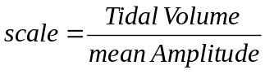 and 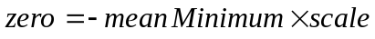
The sample values x are scaled to calibrated values y using.

4.3 Filtering

The output of the filter y is the weighted sum of input values x. If you define a filter, the weights w are set according the list on the filter tab. The filter process is now defined as:
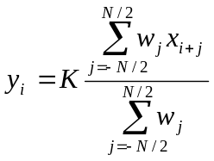
Where N+1 is the odd number of points you entered and K the filter gain. Initially, all w_{i} are set to 1 if the number of points is odd. For even number of points, the number is increased by one and the first and last weight is set to 0.5. This is necessary to create a filter with zero phase shift, but the transfer function is identical to the even points filter.
Typical low pass filter to eliminate 50 Hz disturbance of your signal is created by a filter with N, equal to the sample frequency divided by 50, and weights 1 (note the previous remark about even N). A typical high pass filter to reduce slow shifts in the ECG is created by (5 points): w₁=-1, w₂=-1, w₃=0, w₄=1, w₅=1.

Chapter 5: Customizing your program

In the directory where your program is located, you can create an ASCII file named CarCalFil.INI with a few lines that predefine program options. Order of appearance is not important.

Keyword | =Parameter | Example
StartUpTab | 0, 1 or 2 | StartUpTab=0: Blood pressure tab  StartUpTab=1: Respiration tab  StartUpTab=2: Filter tab  when the program starts, this tab has the focus
DefaultDataPath | Valid directory | DefaultDataPath=c:\carspan\data  If the directory doesn’t exist, the default is used
DefaultOutputName | Valid file name | DefaultOutputName=calibs.txt
LowValues | Value1;Value2;Value3; etc. | LowValues=&0;100;  Note: &value is default
HighValues | Value1;Value2;Value3; etc. | HighValues=0;100;&200;500;  Note: &value is default
CalibrationVolume | Valid number | CalibrationVolume=700  Value in ml or cm³
RecognizersBP | Text1;text2;text3; etc. | RecognizersBP =bp;blood;pres;  Note: a channel name that include one of these string is recognized as blood pressure channel
RecognizersResp | Text1;text2;text3; etc. | RecognizersResp=resp;adem;  Note: a channel name that include one of these string is recognized as respiration channel
DefaultChannelNumber | Valid number | DefaultChannelNumber=2  Note: Used only if no channel was recognized.
MaximumSignalLength | Valid number | MaximumSignalLength=60  Note: time in seconds
DefaultADresolution | Valid number | DefaultADresolution=16  Note: unchecks “Use file A/D resolution”
Nfilter | Valid nubmer | Nfilter=2 Sets the default number of filter points on the Filter tab
HistogramLimit | 0.0< Valid number <1.0 | HistogramLimit=0.5

An example, made by NotePad:

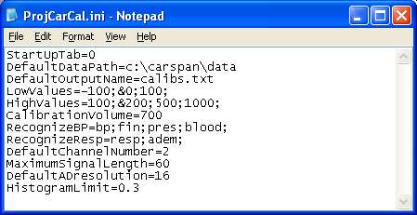

Appendix: Known blood pressure calibration signals.

Four continues blood pressure measurement devices have been used by the authors. The calibration signals are square waves (see also figure of chapter 1) with different maximal level and corresponding High values. The list shows the system used, signal’s maximum and High values.

System | Signal max.  [V] | High value [mmHg]
TNO-BMI Model V | 1.0 | 100
Ohmeda 2300 (Finapres) | 1.0 | 100
FMS Portapres | 2.0 | 200
FMS Finometer Midi | 2.0 | 200

Note that the FMS Finometer series have a three level calibration signal (0, 1.0 and 2.0 V, see figure below). However, the algorithm will usually use the 2.0 V level, so use 200 mmHg as High value. This is because the duration of the 2.0 V level much longer than the duration of the 1.0 V pulses and the mean signal value is below 1.0 V. Only for very short, incomplete, calibration signals errors may occur. The solution is to select the appropriate High value of 100 mmHg in case only 1.0 V pulses (duration 0.4 s) are present.

